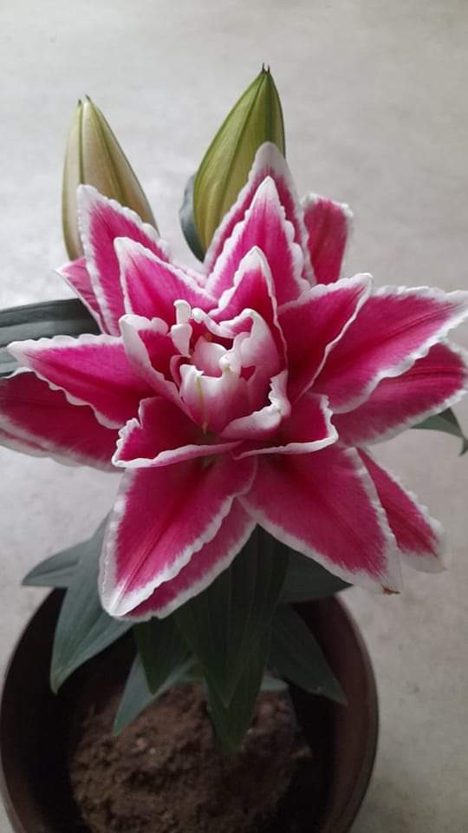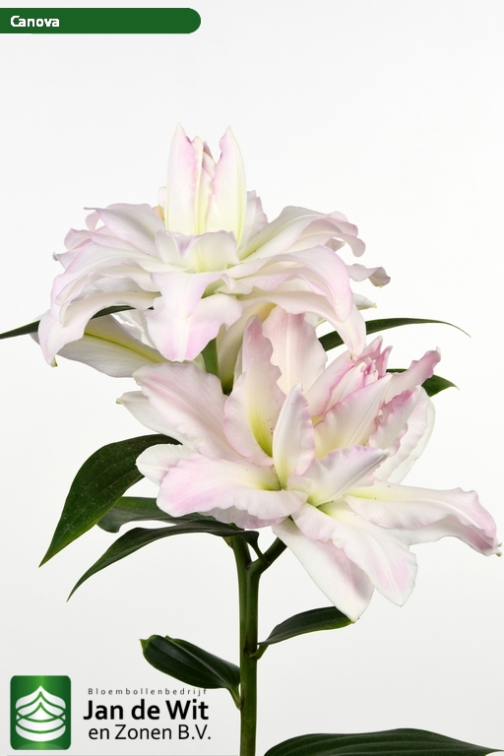 Alanno ORPOT 40 cm Double Canova OR Double 90 cm

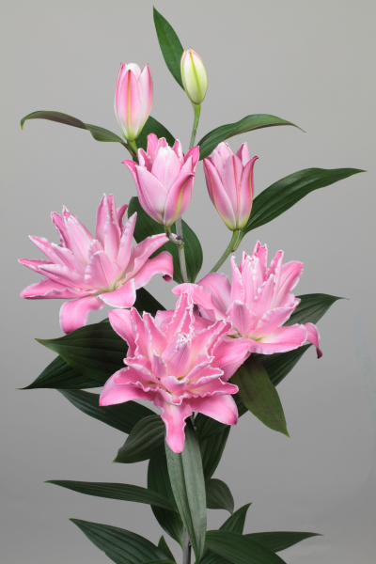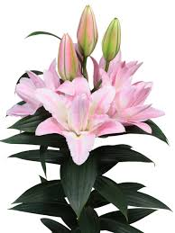

Conamara OR Double 90 cm Concorde OR Double 100 cm

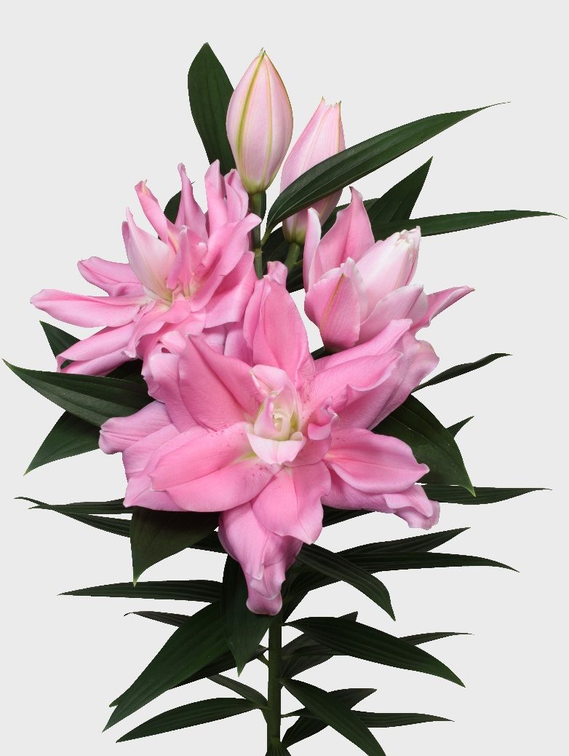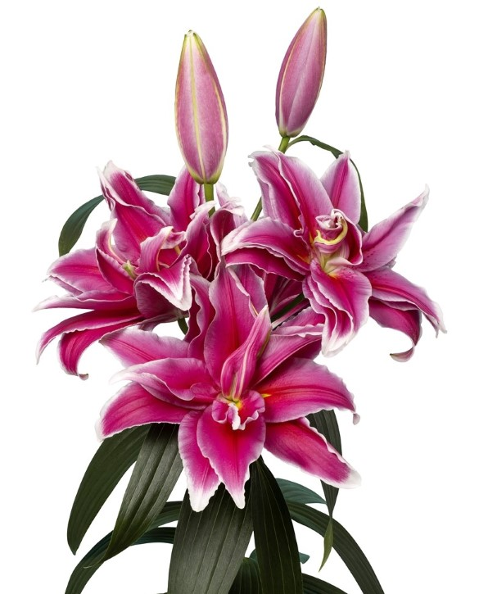

Fabienne OR Double110 cm Rio Marina OR Double 105 cm

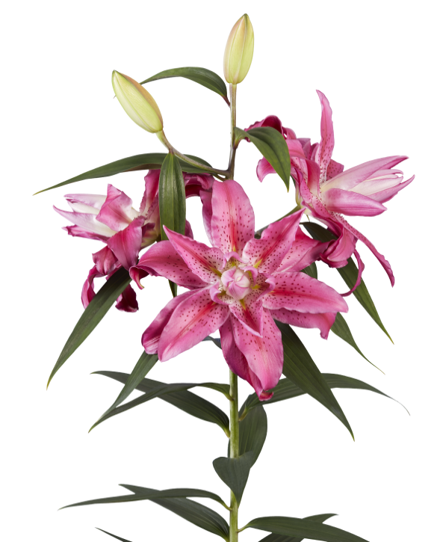

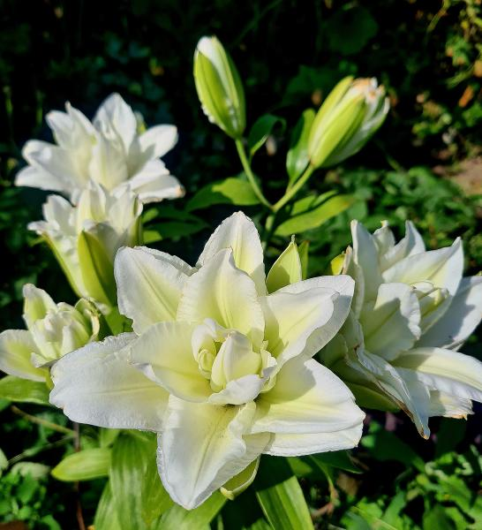 Snow World OR Double 100 cm Valente OR Double 115 cm

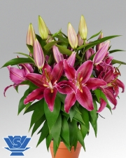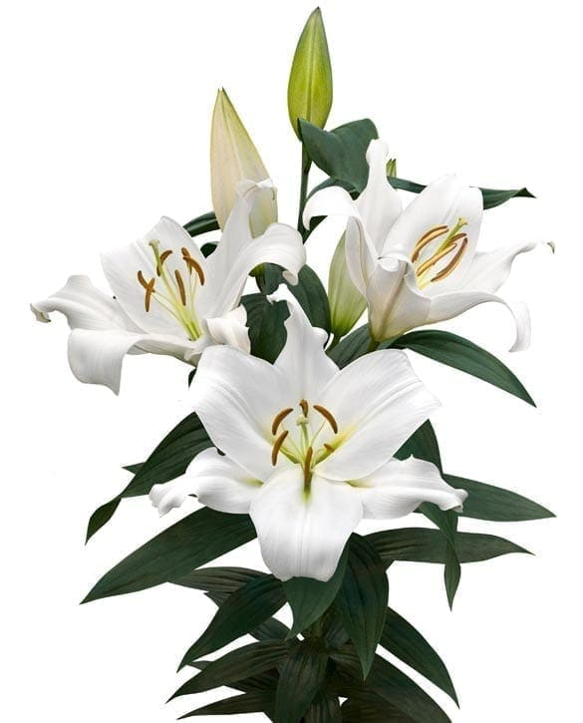

Red Radiance POTOR 50 cm Biscarosse OR 125 cm

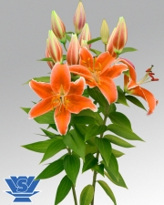

Sunlight Express POTOR 40 cm

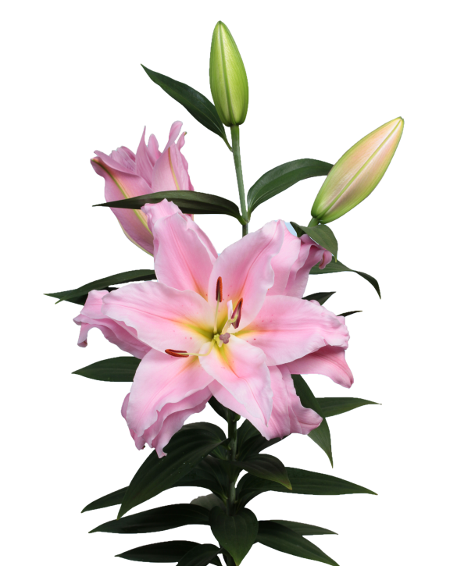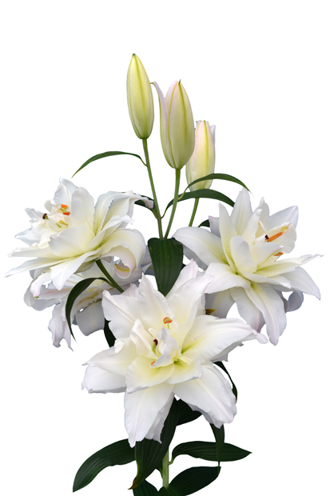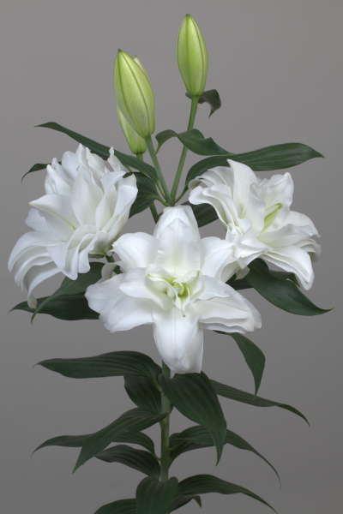 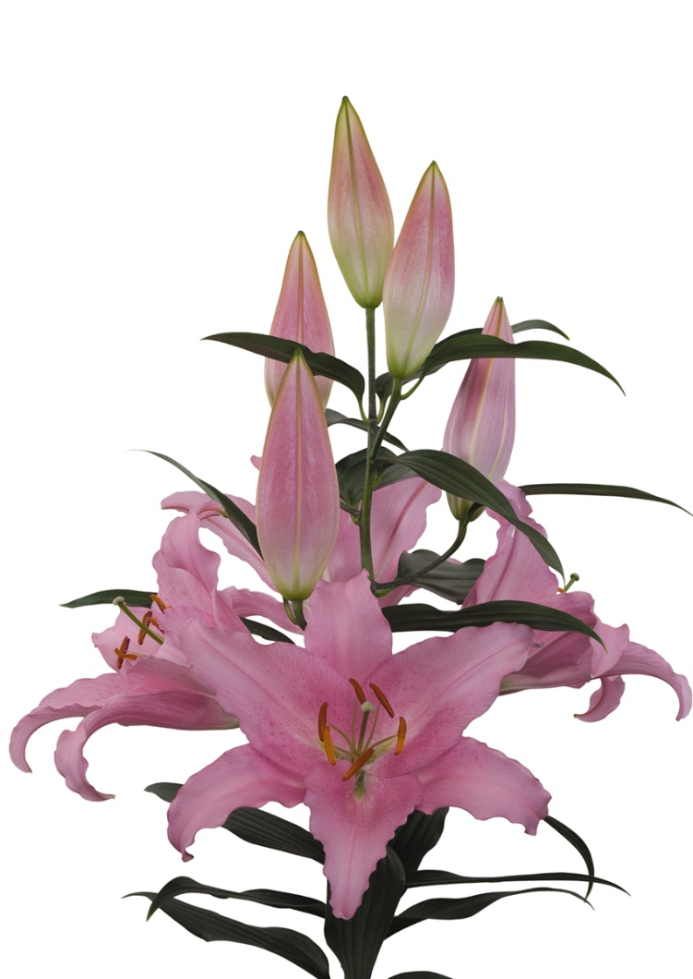 Catone OR 110 cm sancerre OR Double 70 cm

Younique OR Double 105 cm Snowboard OR Double 100 cm

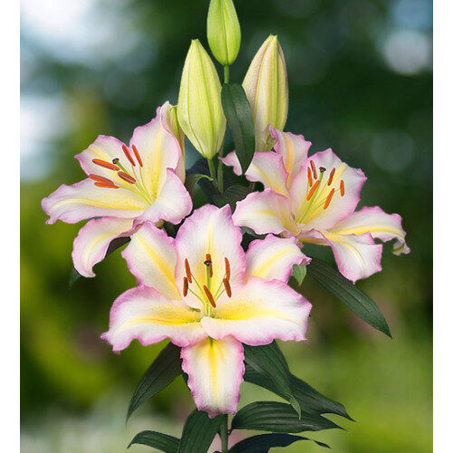 Captain Tricolore OR 100 cm Castellani OR 110 cm

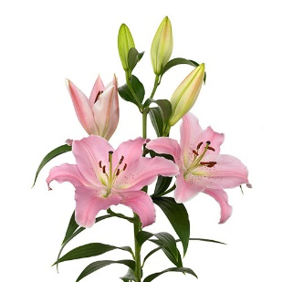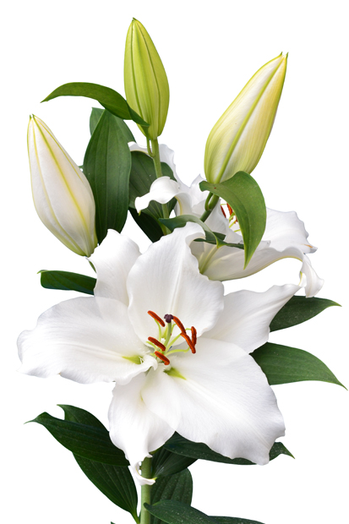 Emani OR 135 cm Premium Blond OR 120 cm

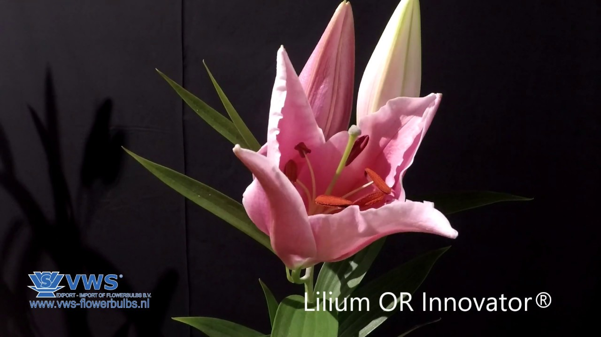

Innovator Or 110 cm

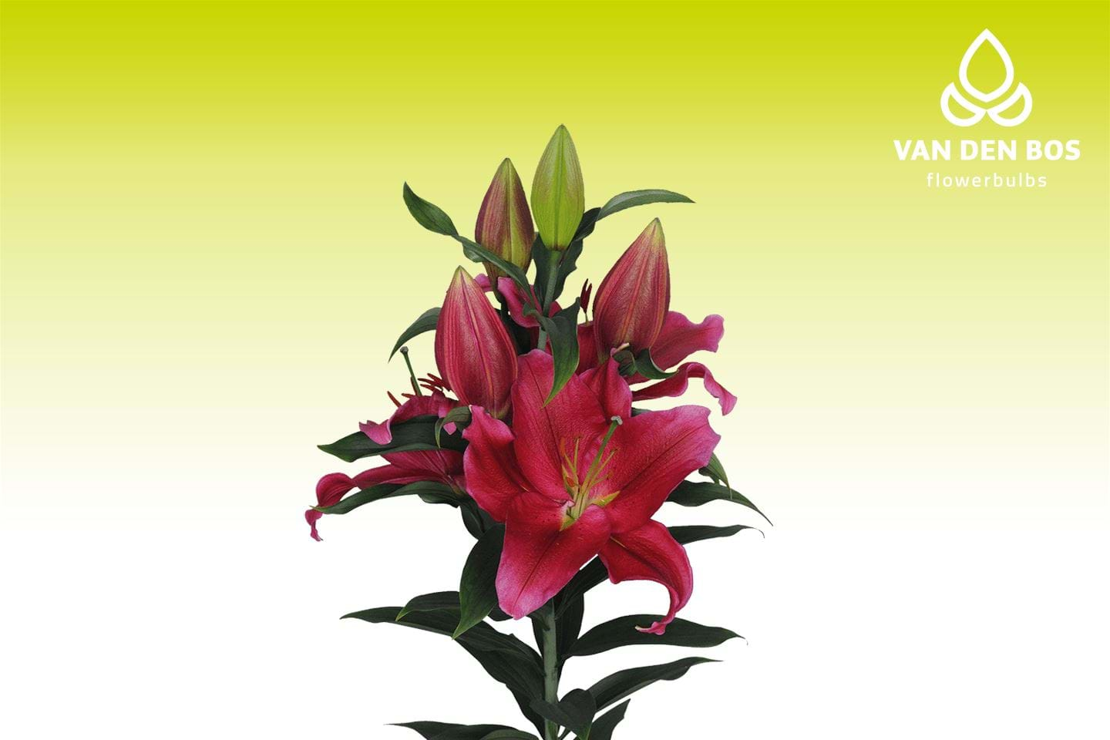 Red Dawn OR 100 cm

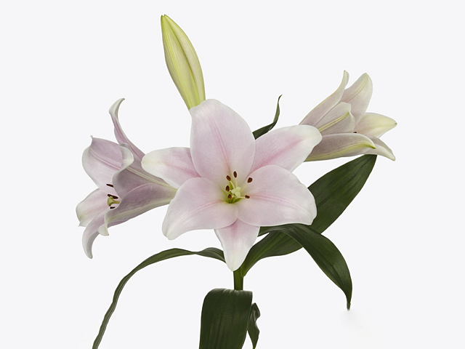

Cali LF 120 cm

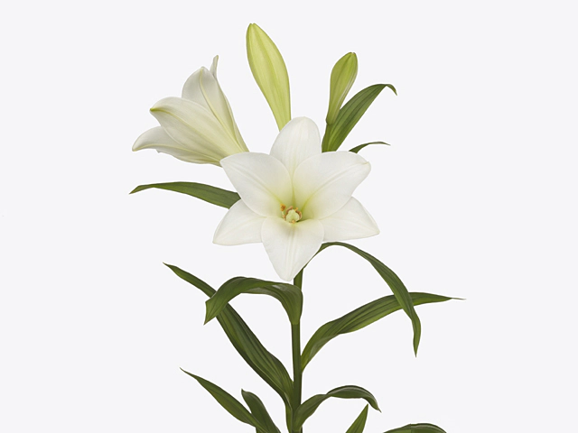

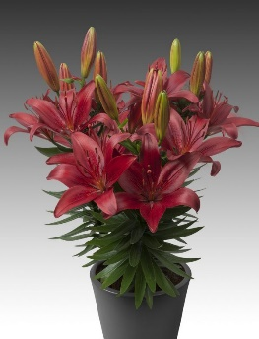 Carpino LF 120 cm

Red Matrix AS POT 35 cm

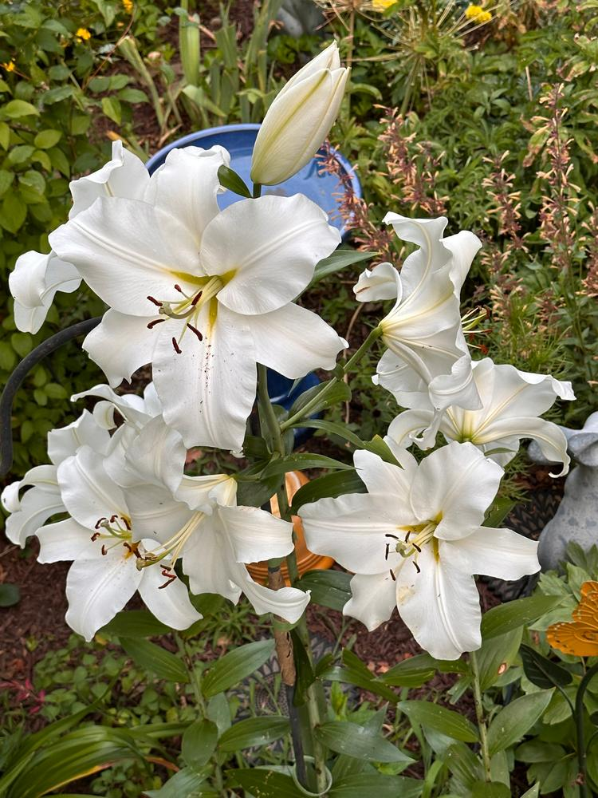Zambesi OT 110 cm med blomster på ca.30 cm i Diameter og en meget kraftig og velduftende aroma

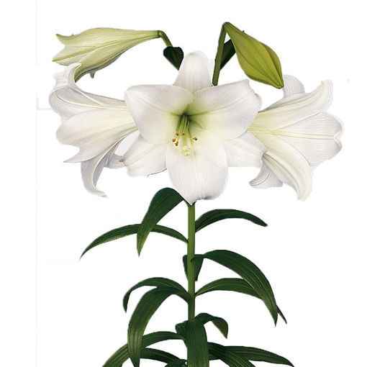

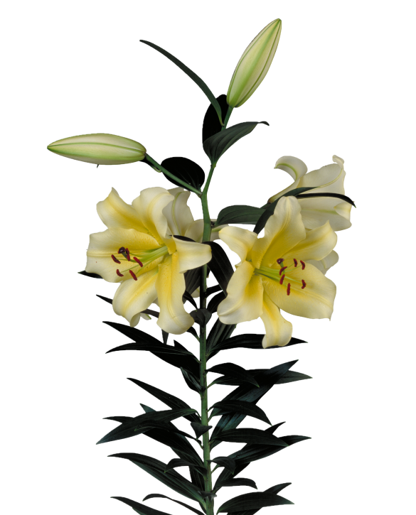 White Heaven LF 120 cm

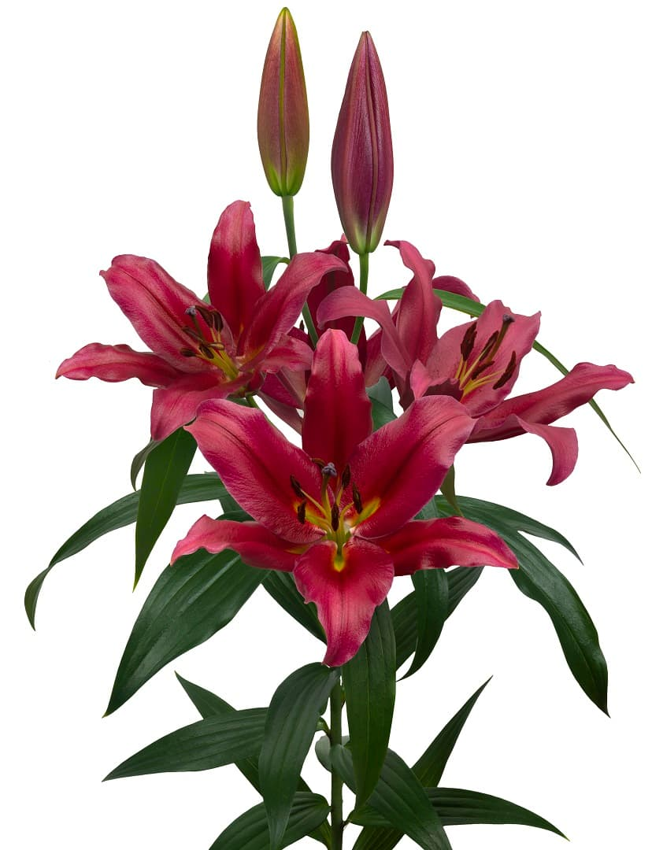 Catina OT 110 cm Bacca OT 110 cm

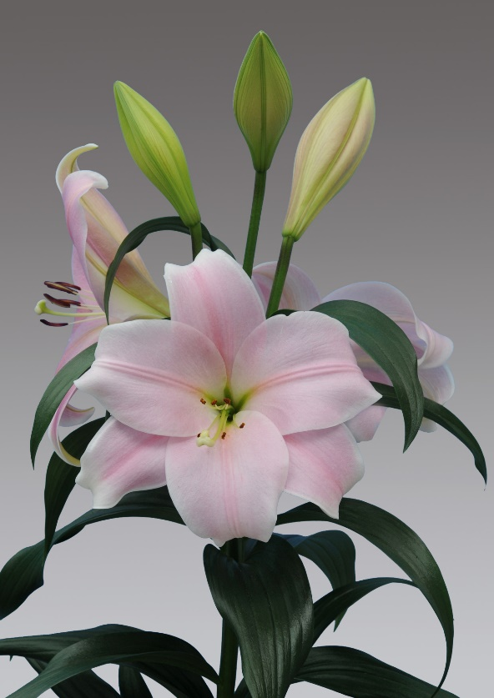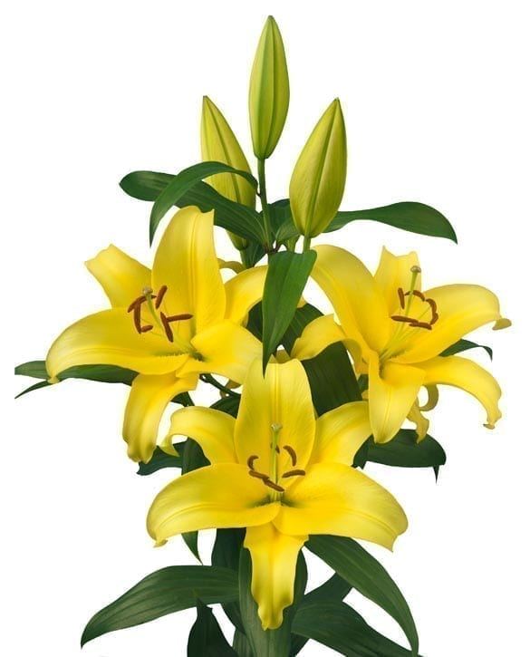 Bellville OT 110 cm New Jersey OT 150 180 cm

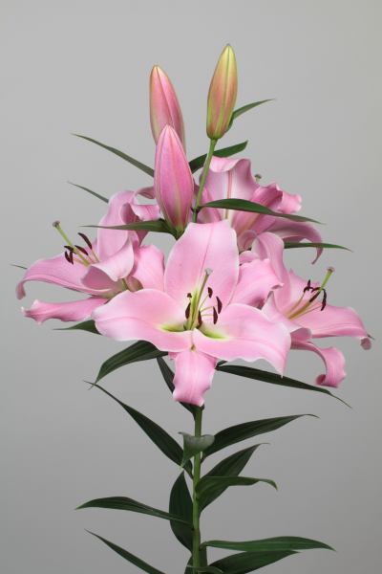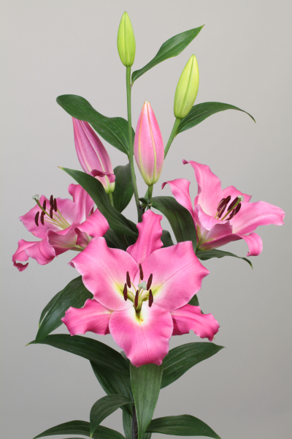

Chiasso OT 130 cm Corinthe OT 130 cm

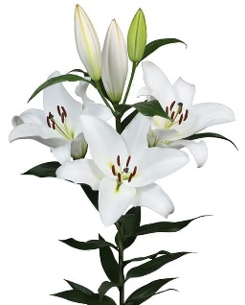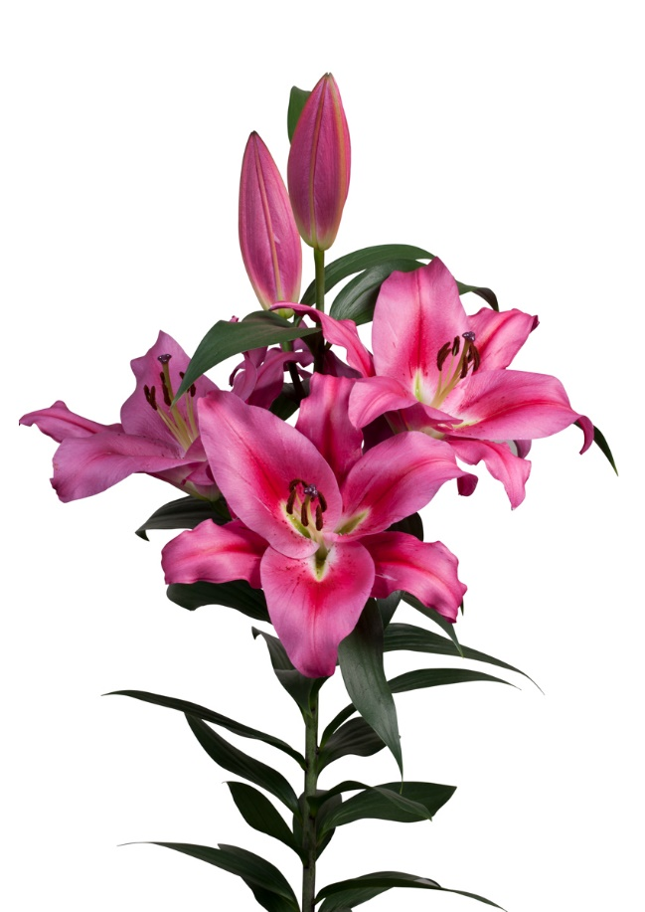

Marengo Ot 100 cm Galibier OT 130 cm

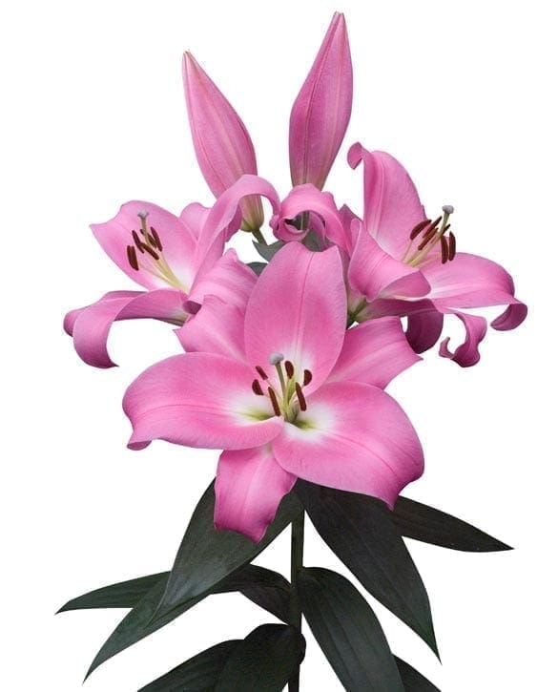 Dharini Up facing OT 120 cm

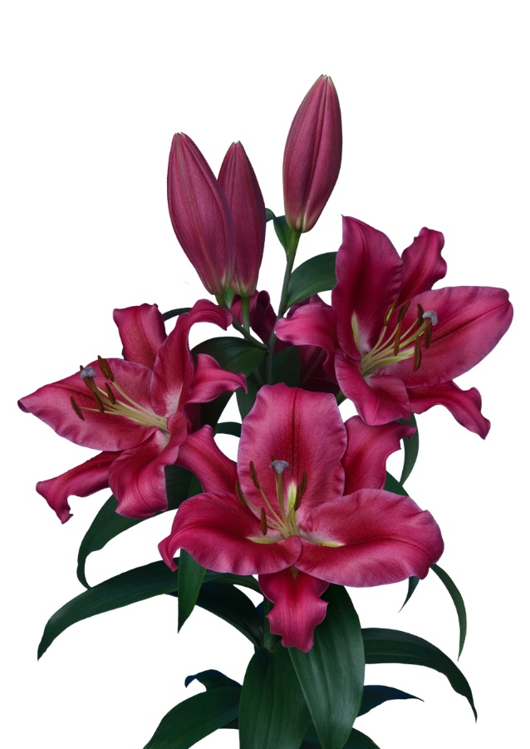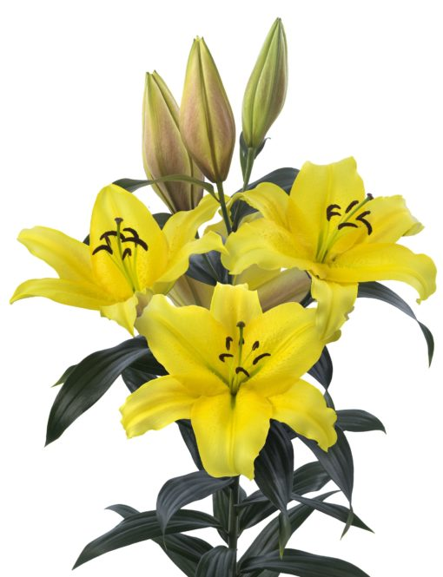

Eldoret OT Up facing 110 cm CARBONERO OT 110 CM

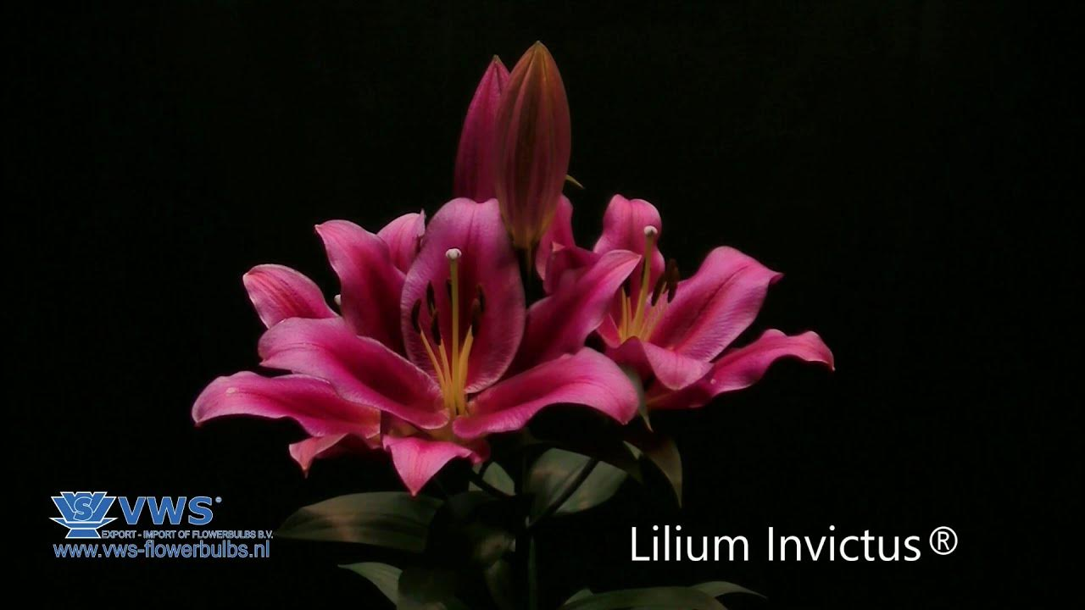

Invictus OT Up facing 110 cm

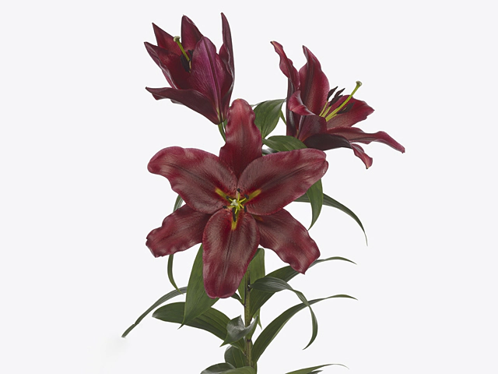 Lasting Love Up OT facing 120 cm

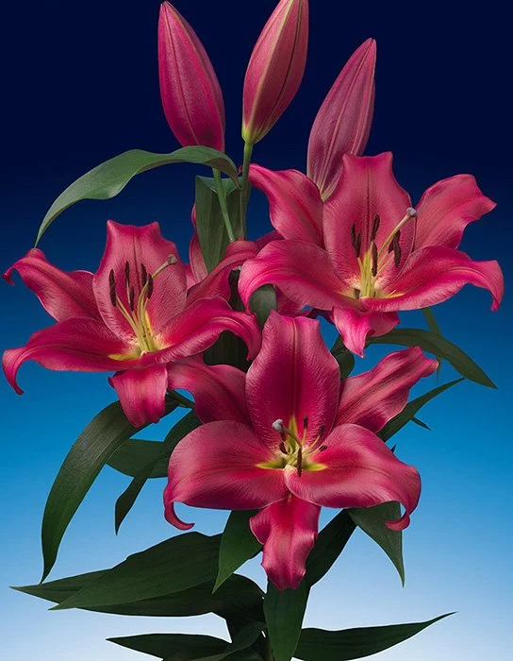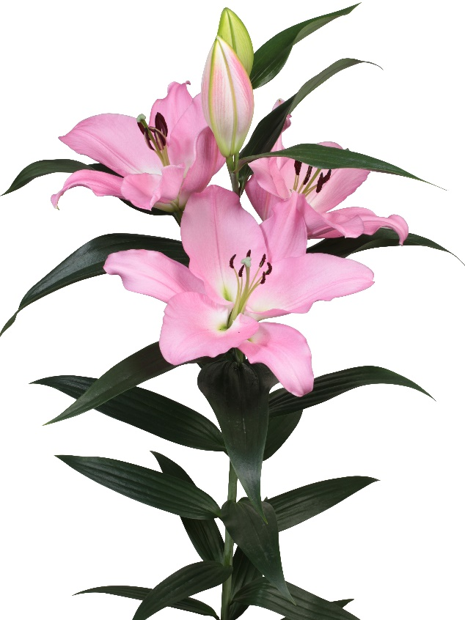

Marchesa OT Redford OT Up facing 110 cm

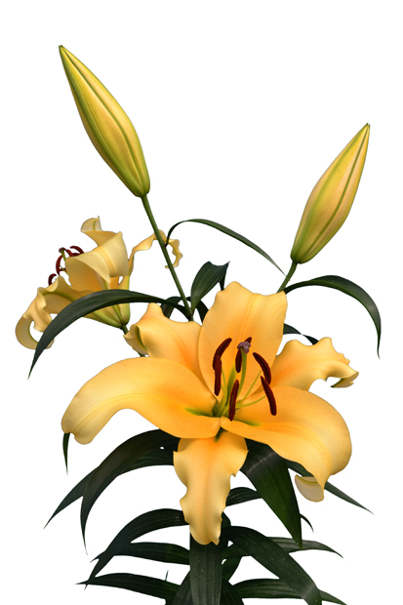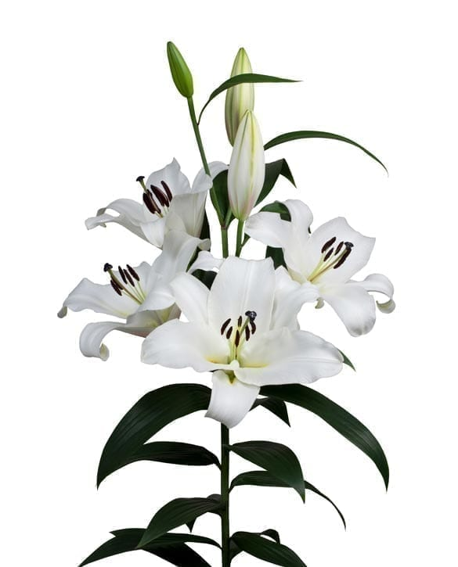Saronno OT Up facing 140 cm Shine on OT Up facing 130 cm

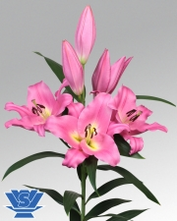Terceira OT Up facing 120 cm Arcato OT 100 cm

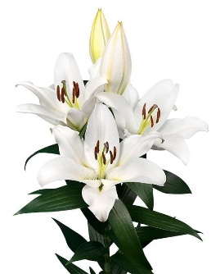

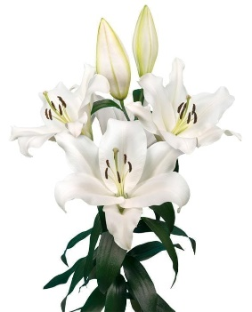

Westminster OT 120 cm Tomorrow 110 cm

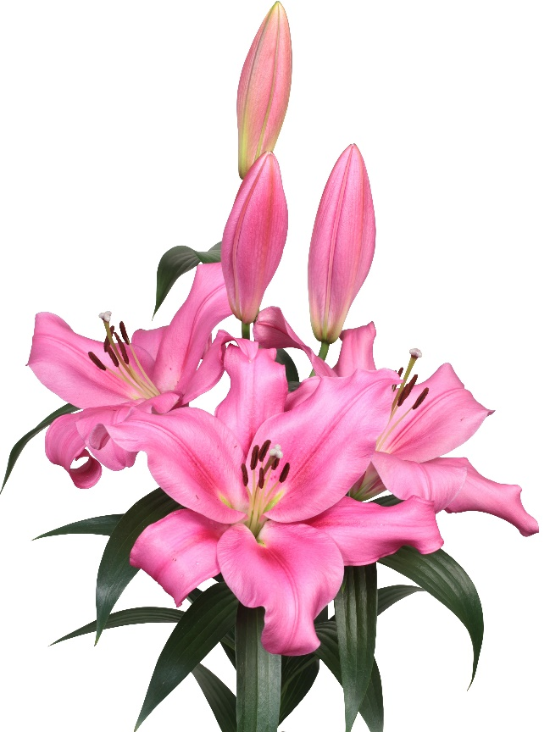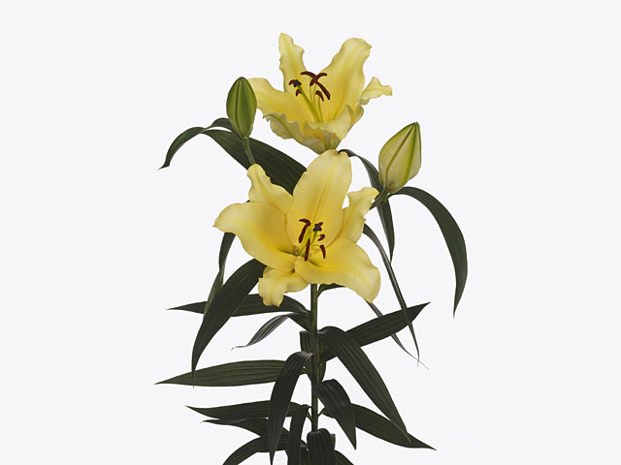

Vigneron OT 140 cm Veneto OT 110 CM